**General Idea.**

The game’s theme is like a tavern where a player can play all sorts of board games, from domino to chess to poker.

All those games are played on a table inside a tavern with candle lights on, and tavern music in the background (listen to this for inspiration: <https://www.youtube.com/watch?v=M0pOMVCUY50>.

I picture an old tavern with all wood furniture, and busy crowds in the ambient environment chatting loudly and laughing and throwing each other around in enjoyment.

**Game 1: Domino**

**Version 0: Set Design.**

* Play the game to set definitions and tasks.
* Design all models and aesthetics of the game first before writing any code.
  + The Table.
  + Domino Board.
  + Domino pieces.
* Setup the scene in unity:
  + Place Pieces.
  + Place some of the pieces.
  + Set up the lighting.
  + Set up the post processing.

**Gameplay Version 1: One player drawing cards (No rotation or logic).**

**Requirements**

* In the beginning of the game, the player can see all cards in front of the camera.
* There are three UI buttons (Left, Middle, Right),
  + Middle: is only active at the beginning of each round when no cards are on the ground, and when pressed, the card on queue is played in the center.
  + Left: is active if a first card is played.
  + Right: similar to left.
* There are three entities:
  + Organizer.
    - Sends a number of cards to the player. (In this version will be all cards to player1) in the beginning of the game and gives control to player 1 to play.
  + Player1.
    - Receives cards and places them in front of the camera.
    - The player presses a UI button, which sends a card to the ground to position it.
  + Ground.
    - Places the pieces on the ground.

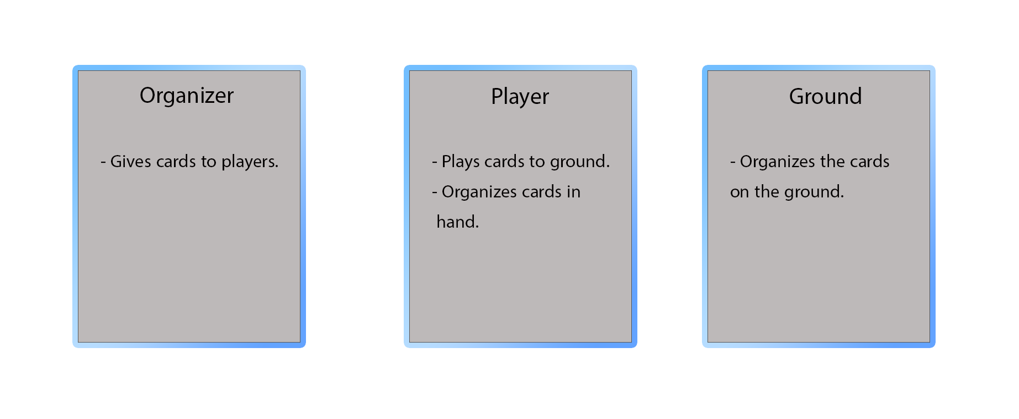

The game initial cycle:

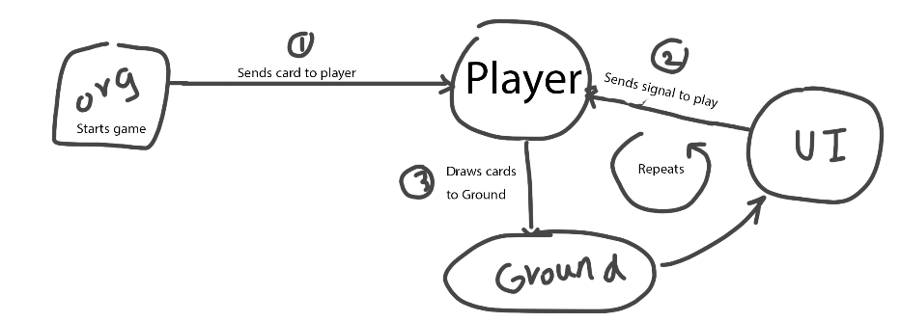

* Design the logic of the game.
  + Version 1.
    - Create Entities.
    - Organize cards in front of the camera correctly.
    - Place cards on the ground in sequence.
* **Gameplay Version 2: Ground Cards Placement (Left and Right)**

Requirements:

* Make Right left center UI.
* Make Ground placement function that organizes pieces with correct rotation and correct position.
  + Make the design of the system.
    - The ability to send cards Right-Left-Center:
      * Center is active only in the beginning.
      * Right and left are always Active.
    - The Ability to select a card:
      * Right and left select Buttons.
      * Selected key.
    - Make cards view from the center not the left side (Player hand).
    - Fix the view if the player has a lot of cards in his/her hands.
    - Fix Selection bug.
    - Change Rotation (Ignore out of bounds problem for now).
      * Create tile class:
        + Defines what’s up and down.
        + Defines wither it’s double or not.
    - Only Allow cards that has the same tile number and play on it.
      * Use UI intractable.
        + Playing on Center card.

Each side should have a functional variable that states what tile number is available to play on.

Play correctly on each side.

**Gameplay Version 3: Card Reorganization:**

* Figure out a reorganization mechanism.
  + Try Axis method.
    - Three Axis: (Center, Right, Left) which change when the tiles are getting out of bounds.
    - Adjust position because of switching.

**Gameplay Version 4: Multiplayer:**

* Look at how to implement multiplayer.
* Implement it in a scene.
  + Add Join/Host Screen.
  + Make players spectate the game (Sync).
  + Make both players manage to play with the same hand set.
    - Try RPC calls.
    - Sync using RPC.
      * Sync player 1 initial cards.
      * Sync player UI clicks.
    - Make randomized card organization and sync it.
    - Make turns.
    - Make a separate card sets for each player.
      * Make two lists, switch which one of them is being controlled.

**Gameplay Version 5: Full Game:**

* Game Menus completing.
  + Main menu, Selection.
  + Join Public.
  + Better preparation to join/host lobby. (Need a room where players can press Ready, and so on).
* Game itself:
  + Fix Bugs:
    - Cards are invisible to guest at start.
    - Players selected card is bind to one another.
    - Remove My cards.
  + Complete gameplay.
    - 7 Cards each and Borrow if stuck.
      * Fix Cards outside.
      * Set cards per each side to be 7.
      * Calculate if a player is stuck at the start of each turn.
      * Borrow cards if stuck.
  + UI Menu
    - In-Game Menu.
    - Win/Lose screen.
      * If one has no cards, he won.
      * If both are stuck, draw.
* Game Design:
  + Zoom-in and Zoom-out.
    - Max Right Card 6, move to 4.416, 1.867, 9.85.
    - Max Left Card 7, move to
  + Remove UI and replace it with new interface.
    - Right-Left active.
    - Right-Left click.
    - Right-Left Position.
  + APK Build.

Start with improvements:

* The game doesn’t join for users.
* Colors (Brown instead), three screenshots.
* Remove UI.
  + Remove Play UI and replace it with green.
  + Green material.
* You need to be able to see the amount of cards the other player has, and the outside cards.
* Your Turn and other player’s turn.
* Flickering light.
* Sound effects.
  + Borrow cards.
  + Play sound.
  + Tavern crowds.
  + UI Buttons in menu sound effects.
* Tavern Music.
* Update Design.
* Disconnection handle.
* Timer.
* Points.
  + Indestructible scoring object, calculate score at end.
  + Access it at end game to save/load score and to decide what to do.

**Gameplay Version 5: Full Game V2:**

Future and Bug Fixing:

Fixes:

* In Room, when press leave, you should go back to dominos menu.
* In Domino room, add title, and title outside.
* Menu, Messages and change it to ready.
* Add Separate screen for host and Join.

Fix bugs:

* Score goes to the other side.
* Score doesn’t reset after games.
* Sliding Mechanism and selection.
  + Sliding.
  + Selection.
* Left and right should be removed and replaced by sliding.
* Tiles need to exist but not show which one is selected.

Bugs:

* Fix the problem of other player’s tiles that gets out.
* Fix Slider boundaries.
* When exit game, sometimes connection problems happen (can’t join another game without restarting the game).
* Other player’s cards aren’t showing properly, sometimes they are less than they are actually are. (When borrowing doesn’t show up).
* Draw round UI doesn’t show for both.
* When Out-cards are done, it doesn’t switch turns.
* Fix Camera Movement.
* When borrowing and out cards are done after borrowing, the game doesn’t switch.
* Game cards diverge sometimes.
* Both player has the same turn sometimes.
* Reset Score after match ends, and update it after rounds.
* Play and Selection delay until it sends the signal over the network.
* Score should show up after game/round ends.
* Timer and the ability to select and play should be disabled when game ends.
* The card played after Double Tiles makes a problem when this double card is played after changing axis.
* When Stuck after borrowing and no more outside cards, it waits for the timer to switch turn.
* After borrowing, it doesn’t check again unless switching.